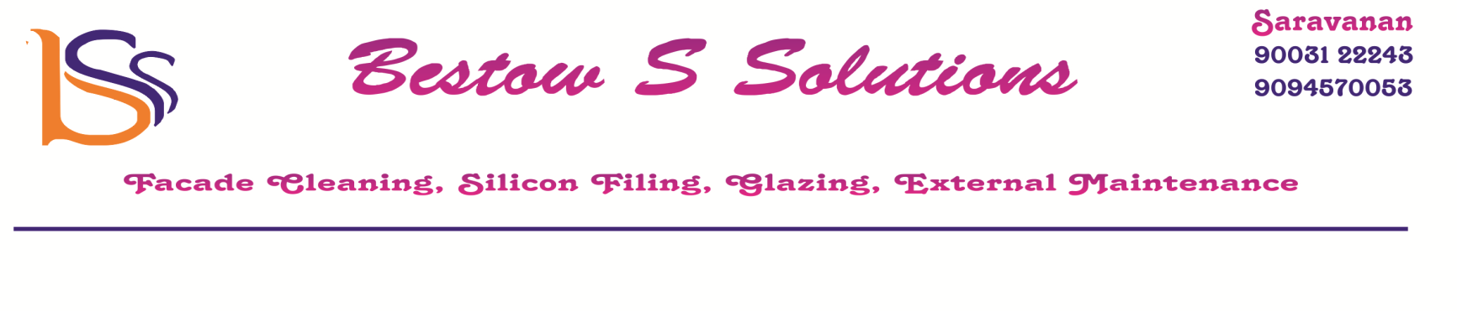
10-04-2023
GST No-33FQJPS5259B2ZN
SAC code-998533
To,
Trends Madipakam ,

Dear Sir,

Sub: Façade/Window Glass Cleaning.

We take up contracts for cleaning of all types of building facades including
Glass, ACP, Stone and Granite.

We Undertake façade cleaning with all types of equipments, scaffolding
towers, long reach poles, Eye bolts, Jibs, Rigs, reach and wash systems
and abseiling also known as 'Spiderman' technique.

As we discussed regarding façade cleaning please find our offer below.
Outer side Trends Sticker Area painting marks Cleaning Charges for Rs.5,800/-
( Including spiderman charges and Cleaning Mettireals.)
We Carry out Cleaning by use of Spider man System.
Payment Terms:
50% along with the work order.
50% on completion of work.
If you need any further details and clarification please do let us know.
Thanking You
R. Saravanan.

